 新津正东街店+詹步蓉+ID5537+13658034879
新津正东街店+苏静+ID4208+13708078264+274723312@qq.com

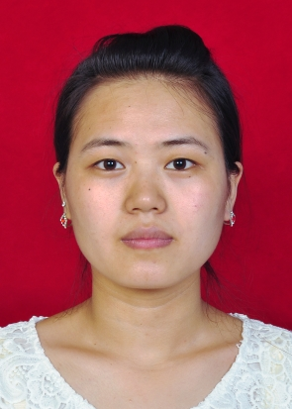新津正东街店+陶明星+ID4192+13881705855+447238136@qq.com

